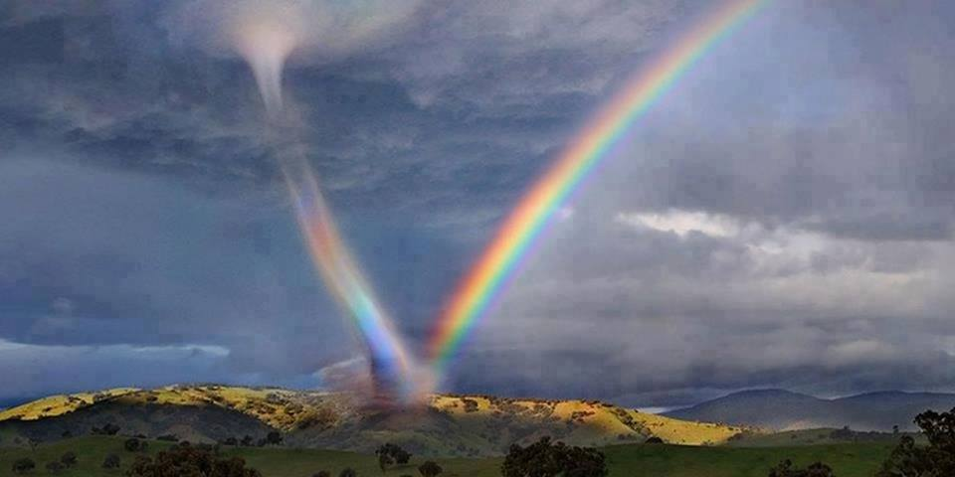

INTERVENTION RAINBOW
Bridges for Peace
Contact : +33623035533 arcencieldepaix@gmail.com
Laure Dupuy

Proposed to illustrate air and water, the work was to see to emerge the colors ... but the only point of humility must prevail, the only concern of this working is to bring smiles in a world that, in some respects, may necessit this approach.

The air and water in front of humanity :

Like air over the ocean writes more than a speech, more than a poem, his moods changing, his torments, his troubles. And the blue of the ocean discusses with the sky. They make waves. One of them imposes the wind, the other one the heaves. They laugh together in white froth. Their splashs shine in the vibrant and clear air. Great air says of himself he’s Power, sovereign water says of himself he’s immense and endless this discourse as indifference leads the marines in the depths, which betwen them float, ignorant and small; sailor between these huge neighbors, are ruefully tiny. Between the blue waves and the air his companion, fish, birds, of each side, fly. One wears the tide, the other the cloud. They clash constantly amount tone, one proves his greatness, the other shoots him blades ... And sometimes the dispute festers and then stops, and on water the truce extends and sleeps, immobile and powerful. The calm goes to the edge, back, forward, tiny advances, tides remote, little waves rocked again, before restart the great discussion between the two giants who speak and still compete for the art of being giant and play together which is greater, more beautiful, stronger.. Ignoring whole smallness of humans which dare to venture to believe that they are so great ... Him which has been made sand or nothing front of this two giants ... he thinks to come from sky. Here, he came to learn the word Humility, yet looking his two feet and with a mammoth ego says, I am, I come and I go when it should, at the foot of the immensity of which he is the servant, drop all weapons, and finally reasonable, shout : I'M SMALL! and now I know.

Laure Dupuy, poetry

August 2013

Plan

Overview

Introduction. A work of artist Project for Peace……………………………………….……..…………………..………….6

- Draft large bridges …………………..…………….………………..…………………………………………..……..….10
- Establishment, triggering a rainbow sky, equipment..……..………….……………………..…..……….….12
- Fountains …………………..……………………………………………………………….…………………..………..……15
- Options ……………………..……………………………………………………………........……………………….……..19
- To go further ……………………………..…………………………………………….………………………..……..….…21
- Participatory Workshops ……………………………………………………………………..………..…………….….22
- The history of the project: It started in Orleans on Bertin rails..…………………..………..…………....24
- Sites : Millau, Gard, New York Lisbon…………………..………………..……………..………………..….…...29
- For cities …..……………………………………………………………………………………………………………………39
- For parks and gardens ……………….…………..……………………………………………………………………….40
- Presentation of the project leader and a team adventure ……………………….…………………………...41

Conclusion………………………………………………………………………………………………………………………………….44

INTRODUCTION

A landscaping project A work of art for Peace

The project is to trigger rainbows with rainwater below larges bridges, using the support structure. To make fall from the top, a drizzle of microscopic water when the sun shines and is properly inclined. This installation will make possible to see in the sky appear after each rain ... a rainbow.
Or on a smaller scale, put a fountain that is triggered solely by misting, at the good hours for a rainbow sky appears, for those who have the sun in the back.
Misting creates a comfortable climate with almost instantaneous micro droplets evaporation.More specifically, the principle consists in injecting water using a high pressure pump in very fine nozzles, causing atomization of the micro drops.Contact with air, a thick fog will form and evaporate micro drops; they travel about 1.5 meters per second before evaporating. The extremely fine micro water droplets allows that the misting system make a rainbow appear in the sky. This is an environmentally friendly process. An options panel with amenities and participatory workshops at the foot of bridges can generate a genuine interest of local and tourist populations, as part of an awareness of the environment.
.
We develop for the first time the project as it was designed for large bridges in the world, and the fountains of artists whose music is set to the appearances of the sun. Fountains for winter, planned for the Christmas lights, like crystal flutes in cities, gardens, parks or public places, before the appearance, thanks to the great bridges, arches sublime in blue sky in the size of natural rainbow, symbol of peace between God and mens (Bible). 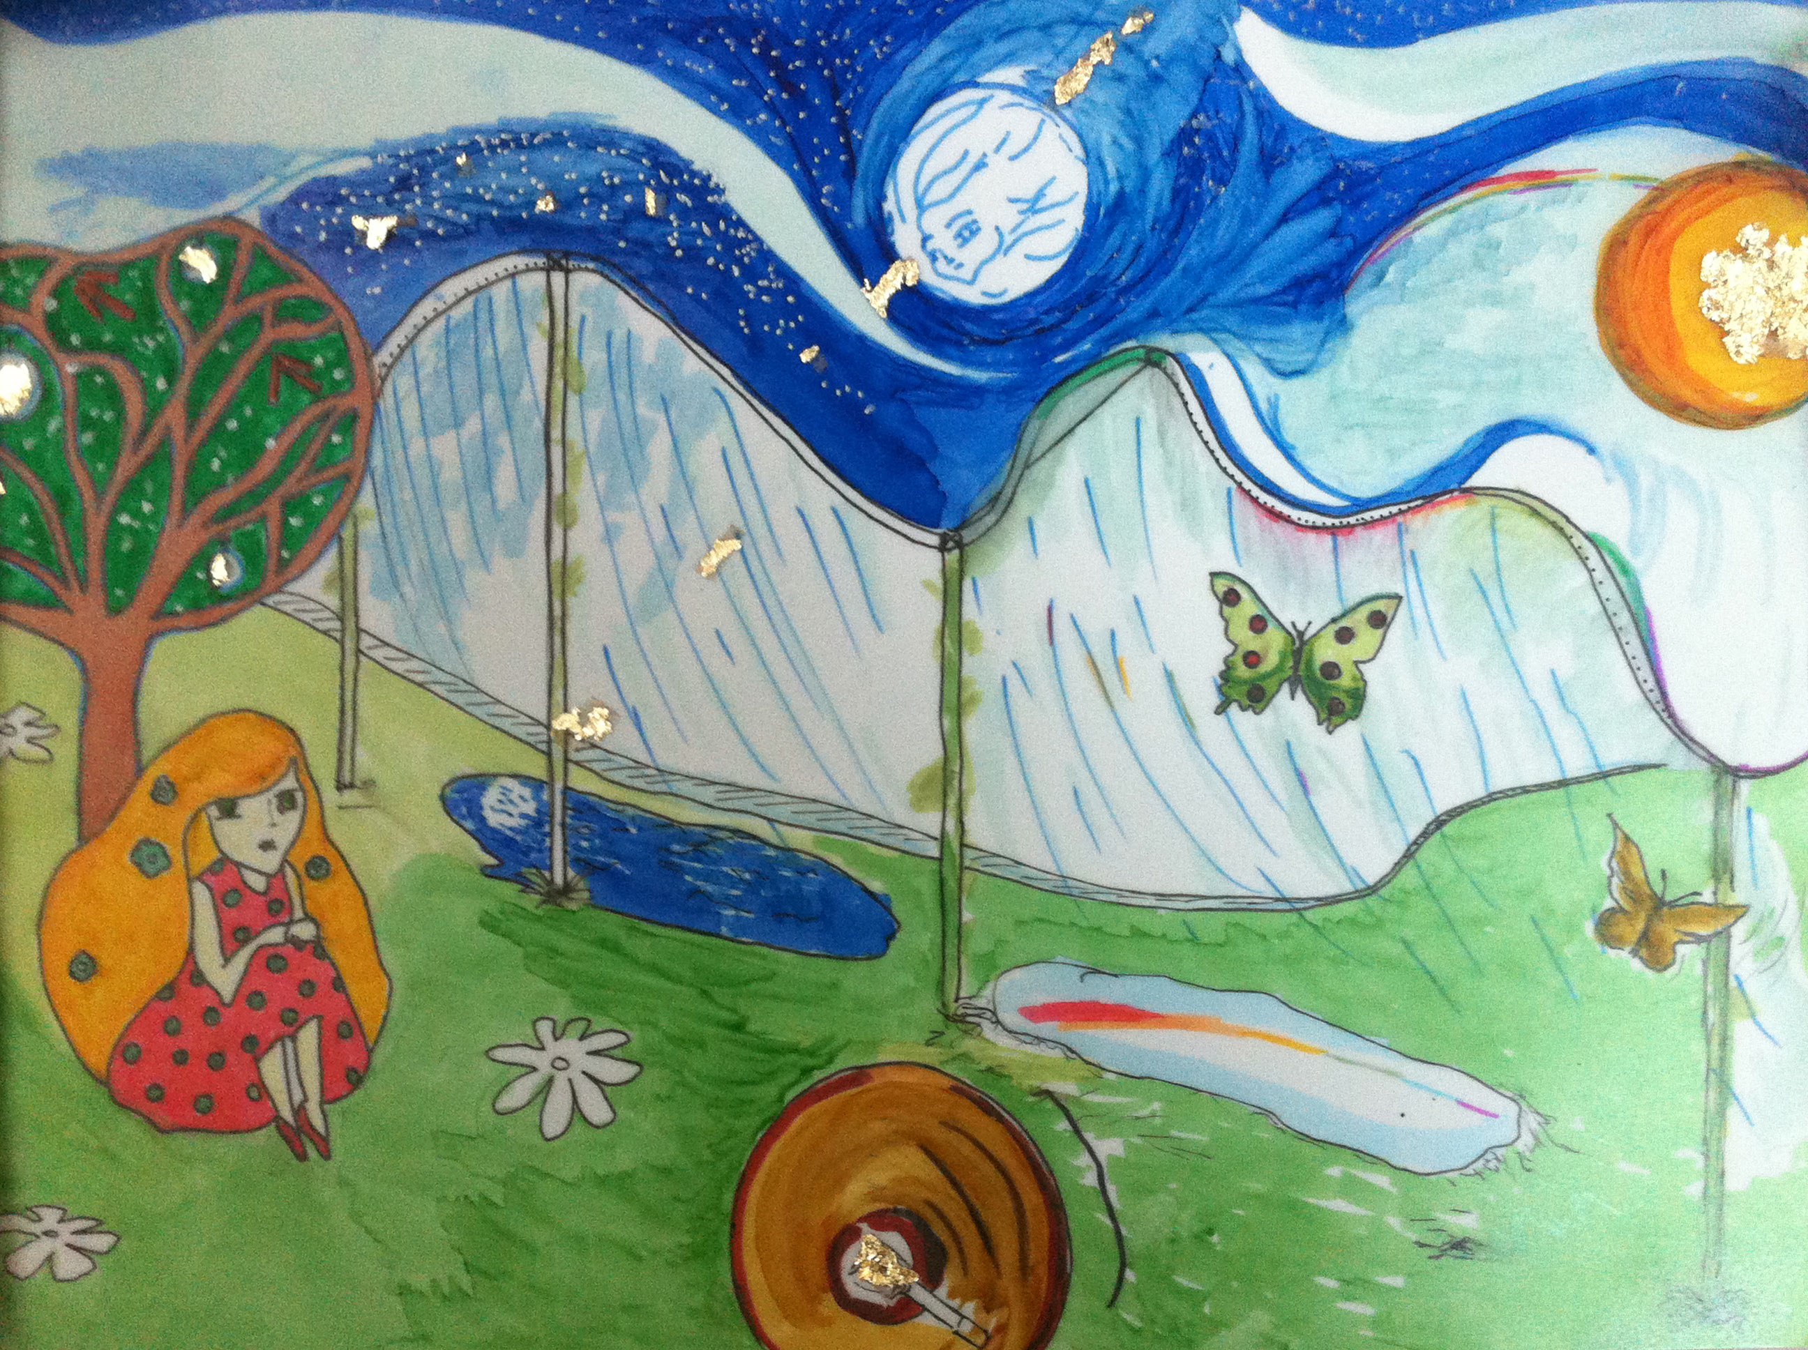
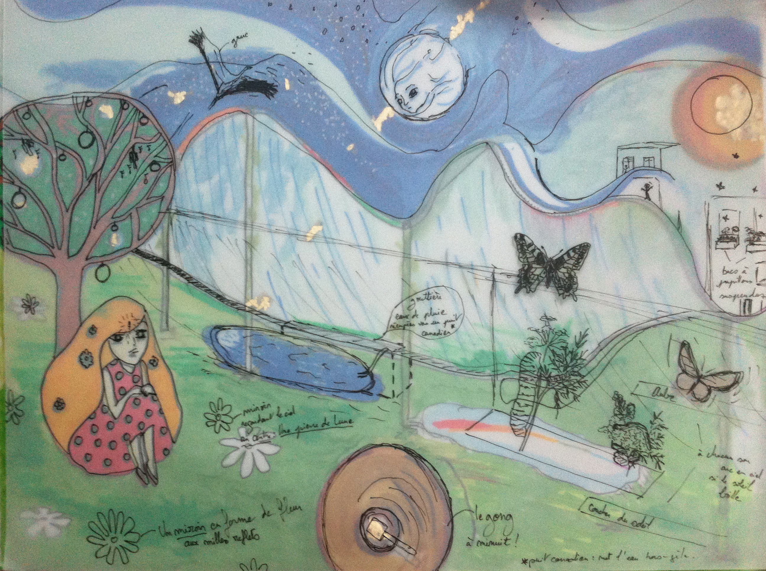
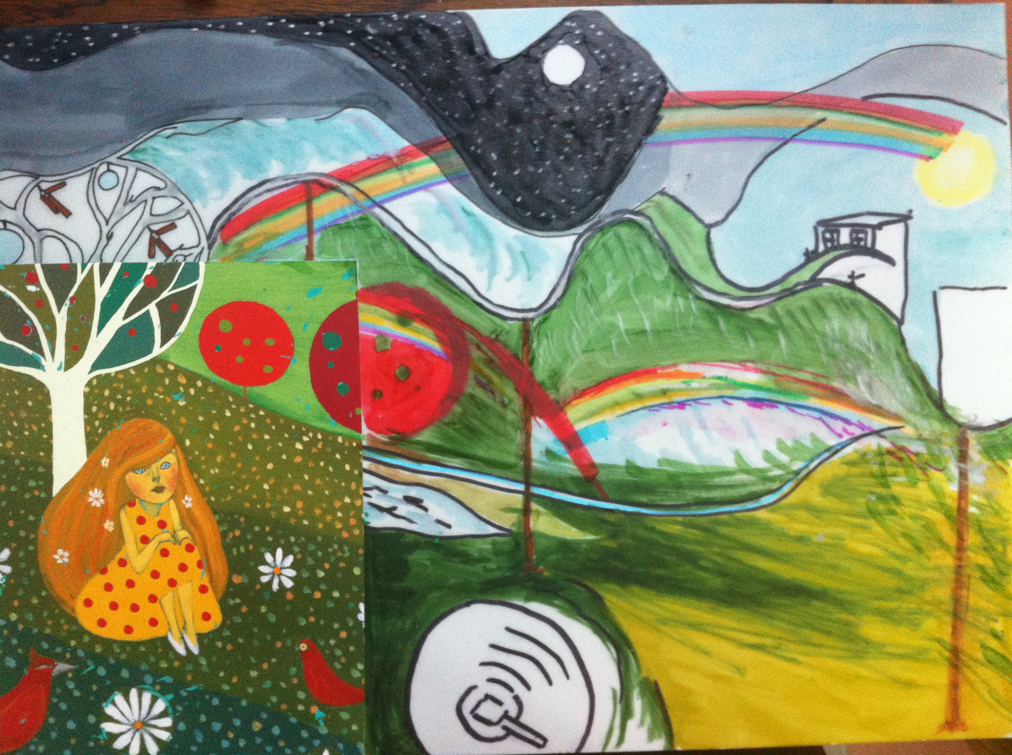
1. Draft for big bridges

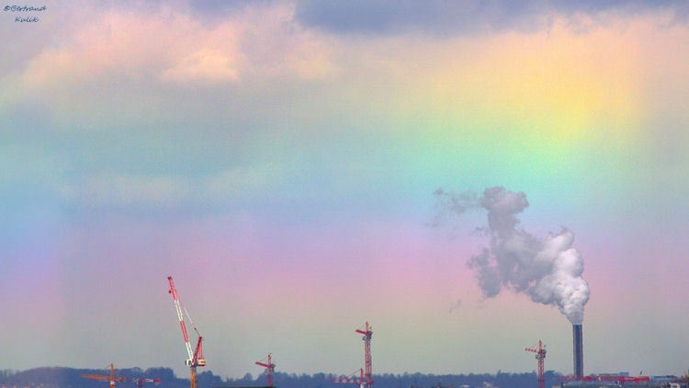
The sites we recommend to accommodate a rainbow
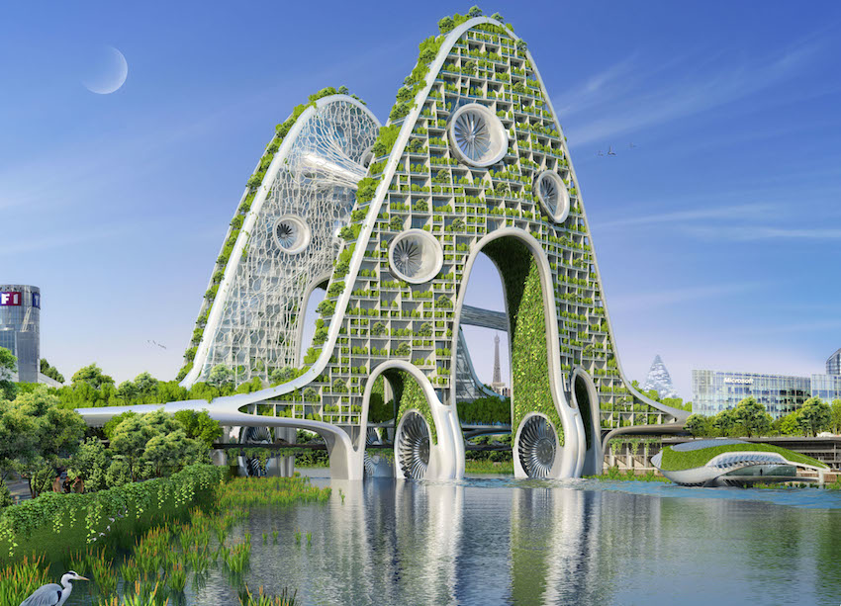
All suspension bridges oriented North-South, which can and must be ecological corridors.
The wildlife reserves: these enchanting places are particularly conducive to the apparition the rainbows in the sky and micro managements of interventions rainbow implemented for the welfare of fauna.
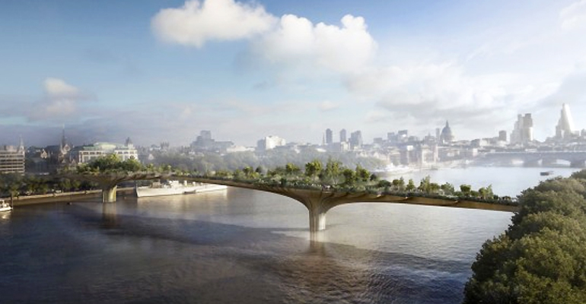Although this actions are miniature, whatever our interventions, they are discreet and effective. Flowered balconies or fountains can also be suitable for facades, public squares and parks and gardens.

Summary of the possibilities offered by our intervention

Suspension bridges in the world are mostly likely to welcome a rainbow, a symbol of peace. The boundaries of the warring countries are also relevant locations, as well as continents entries. Entries in Europe from the Atlantic to Lisbon for example. Inputs of the Americas New York or San Francisco ... Asia inputs by Istanbul, (it conceivable to put a rainbow in the sky at the Cape of Good Hope) for the symbol ....... etc.

Optional: The combination of water and earth elements, through appropriate plants for local wildlife was part of a biodiversity conservation approach and can create some sites of small nature reserves for wildlife (bees .. .).
A spectacle of sound and color includes chimes using the presence of the wind.

The visibility of natural elements (wind, rain, sun through the rainbow sky) through the implementation of a kind of symphony redistributing the "water" element of Heaven at hours of sun. These intangible element allow, at the time of the rainbow sky to gently introduce the subject of nature and entering the field via the language of art and landscape, incorporating the plants and foods of small wildlife under these controlled rain, create an ecosystem related to the misting and native flora included in the development.

This is a project that encourages social cohesion by developing local life around the theme of education to the environment and visitors can take part, through prior consultations with developments in various activities related to wildlife and environmental education. They are invited and welcome at every stage of the implementation of various activities dedicated to all, through associations defending the natures, volunteers and / or extracurricular activities described below.

2. Installing and setting up the rainbow sky device

A solar collector made of solar panels and switch triggers the mist fountains that draw their water from ponds, rivers or lakes, or are connected to a water supply, and microdroplets falls when the sun shines below 42 ° elevation morning or evening.

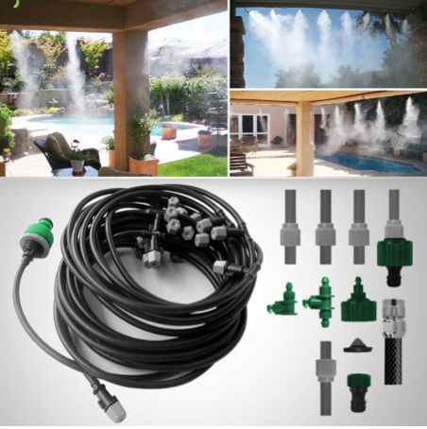

Trigger a rainbow

1. How do you do?

Who knows that, to see a rainbow, you must have the rain in front of you and the sun in the back?

This means that in the morning we will see the rainbow looking toward the west, and in the evening the contrary you will see the rainbow looking toward the east, when a wall of droplets shines in the air on the side where one looks ....

The arc-en-ciel training after rain is a natural phenomenon related to the scattering of light.

A rainbow is a natural spectrum of sunlight that forms in the sky when the rain drops of water suspended in the air are doing like prisms to disperse the sunlight into the colors of the world.
Primary arc : a primary rainbow sky is formed when the sun undergoes two refractions and reflection. A primary arc is red color in the outside of the curve and purple inside.

Secondary Arc: a secondary arc is formed when the sun undergoes two refractions and two reflections in a drop of water. Sometimes a secondary arc is formed over a primary arc. A secondary arc has the color purple on the outside and red on the color of the inside of the curve. Is the double reflection of the light. A primary arc is brighter. The double reflection of light in the water droplets takes place in the light scattering.
Equipment used for large bridges.

PUMP HIGH PRESSIONDébit variable from 0 to 12 liters per mm (3.0 gpm) 230V 50 HZPuissance 2800W Voltage (1400 W 70 bar) Size 350/200/200 (jet 2.5 meters) - A TIMER C'est a timer, its role is to drive the pump and set the duration of a fogging cycle and frequency on a 24-hour fully automatically.
Technical description:
Water supply, filter, high pressure pump, line with nozzle holder and nozzle, end of line plug (it will provide a water treatment to ensure the proper functioning of the installation and rainwater collection if the buyer wants to go through with the ecological approach)
- Kit 500 standalone linear meters (solar)
- HP Tube OD 8 mm (semi-rigid nylon material) Operating pressure 60 bar
- Crown 100 meters
- Pipe ring
- Hp touch fitting for tube
- Barrel nozzle holder 10/24 F
- Barrel Double nozzle holder
- Elbow
- Tip G1 / M4 08
- Plug EOL brass
- The nozzles, three body parties Série brass stainless nickelé Série
  - Buse 0.08 / 0.017 liter minute, Buse 0.010 / 0.03 liter per minute
  - Nozzle 0.020 / 0.07 liter per minute, Buse 0.030 / 0.13 liter per minute
  - Buse 0.040 / 0.17 liter per minute
  - Buse 0.050 / 0.21 liter per minute
- - Tablet, ruby or ceramic
- - Anti drop spring stainless steel
3. Fountains, see company
Photo-sensitive fountains are misters that trigger to sunlight for hours conducive to shine to get rainbows. These are artistic works for Peace

Datasheet :

Innovation.

Our company distributes fountains that can assimilate to water games in the parks of some castles; but gives to basins and in public places the possibility of an artistic and musical performance organized by the sun, since the fountain starts to shine when the sun is in the right place and triggers a rainbow sky.
Provided the decked area be looked in sun is a simple, but complete show which, controlled by the rays is offered with a range of ecological development, micro-facilities, including the presence of wildlife through feeders , nesting boxes and butterfly plants, etc ...
Facilities related to the recovery of rainwater are more costly for the buyer, but will go through this process of creating, together with an artistic performance, small ecological reserves. In this case, after each rain, a rainbow sky will be triggered by the first ray of sun shining at the right time. (morning or evening depending on the installation).
However, facilities that are not related to the recovery of rainwater will run every day from the sun.
This concept of development of the preservation of the environment in an artistic setting is completely innovative and will delight the spectators.

Artists of fountains

Using rainwater and giving it to the sun, the artists of rainbows-fountains offer a miniature representation of the first rainbows whose appearance is mastered by man. The morning or evening sunlight trigger these musical fountains on wind air in an environment where the sunrises arc-en-ciel will serve light pretext for all kinds of light and water games by flirting with heaven and nature.

Christmas Lights

The decor of the public squares at Christmas time seems to be the ideal place to shine amidst the "Waltz" of lights of winter, a unique game world punctuated by appearances from sunlight. In cities that will host our "flutes" fountains evoking stalagmites, the rainbow sky glow in early morning and late afternoon, it will not compete with the lights of the night, but will add to the magic of chrismas celebrations.

For parks and public or private gardens

Installation

The installation of the fountains in the landscapes gardens allows us to offer added value whose treasures are at hand and only sometimes ask to be arranged in harmony with nature, with some inventive touch invented with the intention to please wildlife.

The collect of rainwater feeding the fountains from the eaves of a house or the natural waterways is consistent with the ecological nature of the project ; however, for a lower cost it is possible to make accessible to all : the fountains can simply be connected to a water supply.

To go further than buying a fountain and embark on the expected ecological development in our "intervention rainbow sky", our options are available à la carte. These projects require a meeting, diagnosis and the creative contribution ￼of the buyer in the choice of options to create her garden.

If we integrate a menu of options for small wildlife, rainbow sky interventions takes part in in the ecosystem with planting native flora needed for wildlife.
The development of natural landscape is sold independently of the fountain and may well be the prettiest part of the show. Among the little creatures of nature that must feel invited, we can choose what we want as butterflys, planting the plant on which it depends.
Invite in our gardens, waterer or feeders, animals - such other natural inhabitants of our magical land where everything grows and rises together - the project is a way to teach the nature and reconcile with it. Search for harmony more universal that participates in a message of peace between man and his environment. The goal is ambitious but achieving that simple...
These developments will meet the following keywords: environmental engineering, playful environmental education, beauty and simplicity

A la carte options, the fountains are sold only in an intervention where rainbows in the sky.
The intervention in rainbows, it's more than fountains, it is a landscape intervention on the air of peace and in the natural context in which nature and people are invited into the natural sites.
Sons
• The show "sounds and colors" can include chimes in trees using the presence of the wind.
• A musical option that we have designed for fountains on a wind tune will sound the same in time than the appearances of rainbows ... (to discover on our site).
• If small or large rivers are flowing on your sites, little water mills (from 40 cm height) may be willing for produce the energy needed to operate the devices (lights on trees) and, crystal clear water, will participate in the harmony of the moment while integrating the use of clean energy.
• A gong will sound at midnight hour of silence and black necessary for animal life. This option involved in environmental education recalling these important schedules an appointment with the stars ...Games with sky lights: stars, moon ..
• …and small mirrors reflecting the stars and the moon, placed on the ground, will make sense when the hour of the gong sounds.
• Small phosphorescent objects in trees can be used as a night show, still playing with the sky.
• Very small bulbs energized by the rain water falls and hung in trees can also be installed. These loupiottes should shine as lights the stars in the eyes of children.
Minerals
• The mineral kingdom can also find its place with micro-inserts tiny semi-precious stones on the site. Some moon rocks and other soft stones contribute to the health of plants and introduce another educational theme : the lithotherapy, alternative medicine too little known by men, bringing its benefits to the landscaped areas. One of our sites http://pierreguerisseuse.wordpress.com can serve as a benchmark in providing the benefits associated with stones. In addition, pyrites or copper dust mixed with soil realize the legend at the foot of the treasures in the foothills of rainbows.
Plants and facilities for wild animals.
• butterfly plants can be the natural element which will give even more colors to our envolée skyward. These plant lines are the simplest (see list on our website for sets).
• Nesting boxes are also available on catalogs according to the species of native birds and desired
• and limestone walls put for fauna insects if you want to raise low walls dedicates to the observation and housing of lizards ...
For maintenance of the garden, a page is dedicated to the site of rainbowmakers.net http://lauredupuy.wordpress.com/pour-les-insectes/les-espaces-verts/ which helps for maintenance an ecological garden. Each facility is expected measures and shall be subject to a specific study.
Projection of the rainbow to 7 meters high or projected from a facade height .

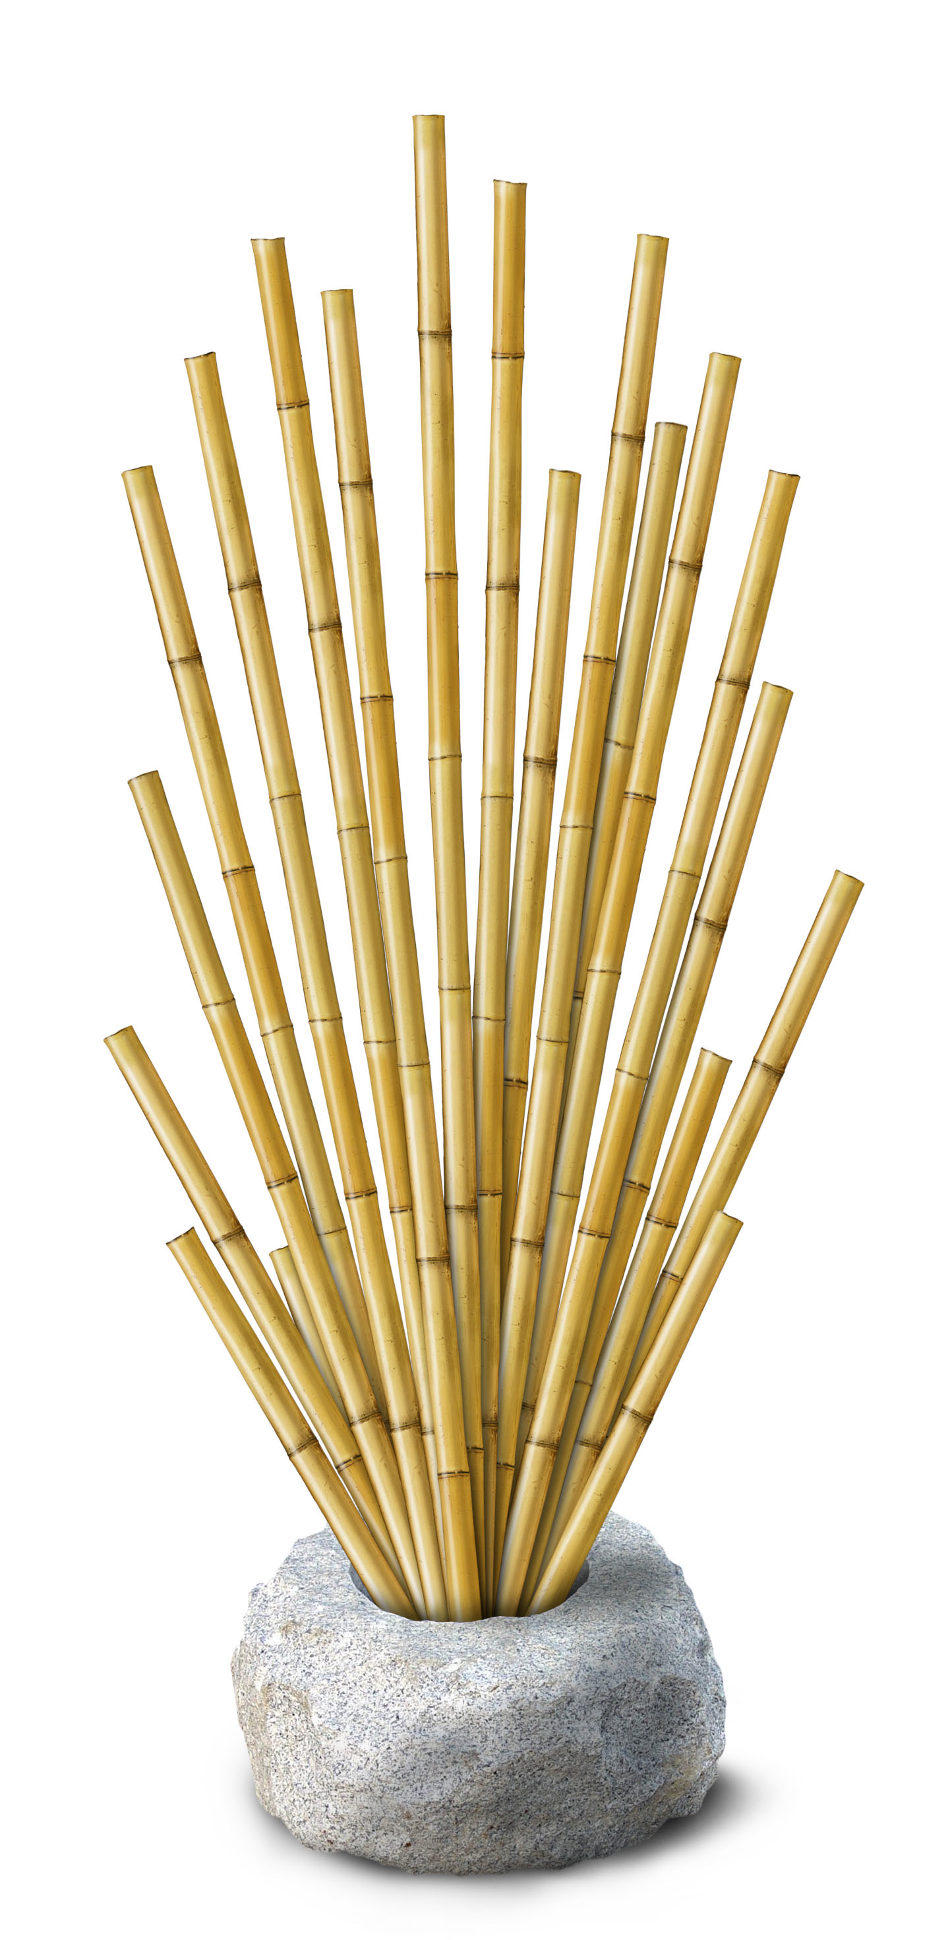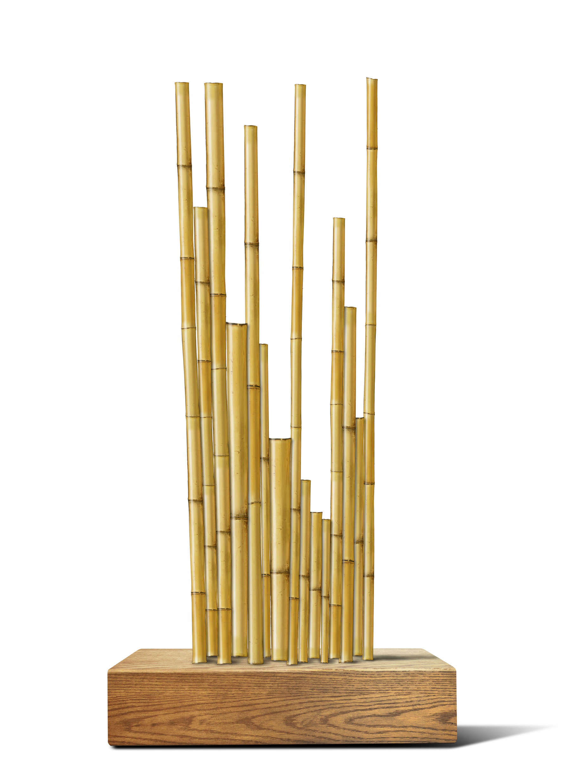
4. Options for larges bridges
The options are install for a sustainable management at each site hosting this new and highly volatile art:
Butterfly plants installed below the arc in the sky sunrises, nest boxes embedded in the landscape, feeders, play of light flirting with the sky or any other specific layout adapted to each site, local Ecosystem Approaches and needs of species specific in place, as amenities to migratory birds or endangered species through comprehensive faunal surveys, in the spirit of recycling and the provision of elements and native plants to promote the harmonious presence the small wildlife.
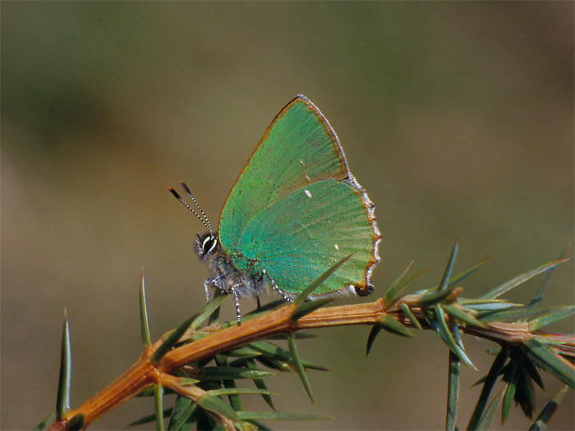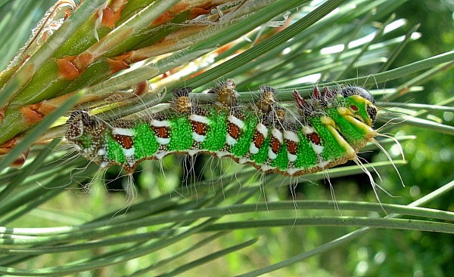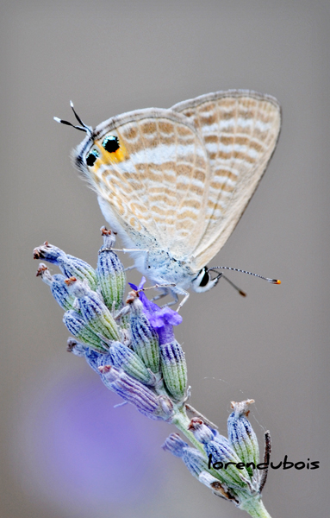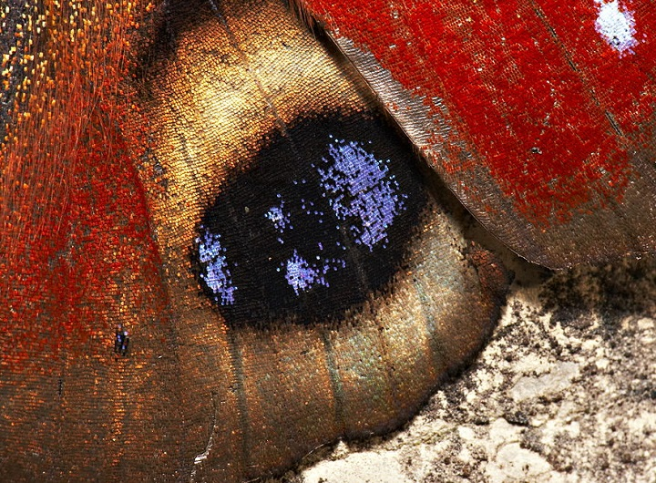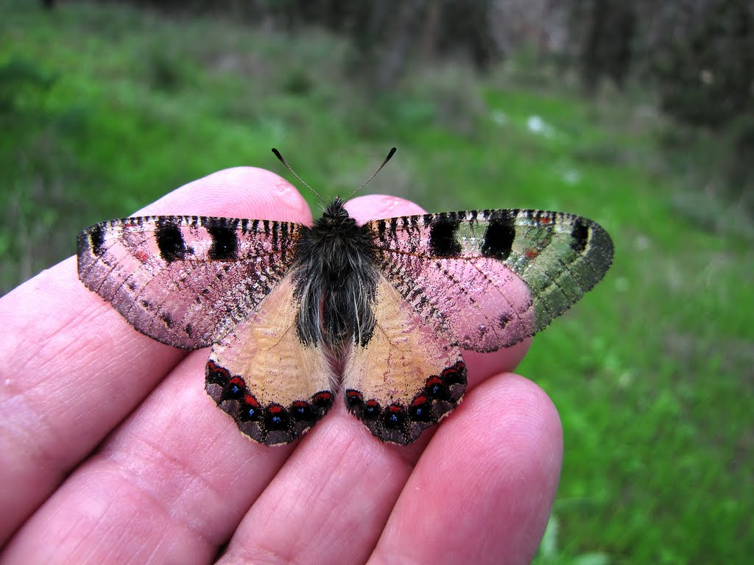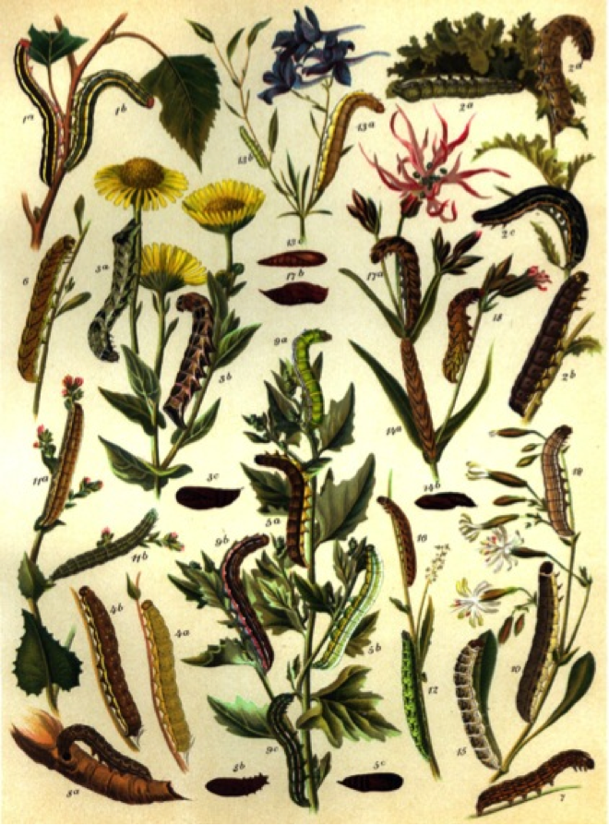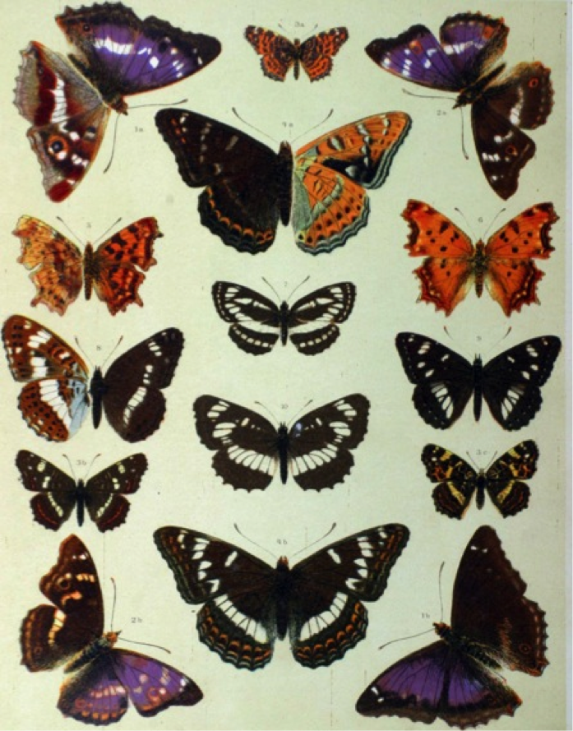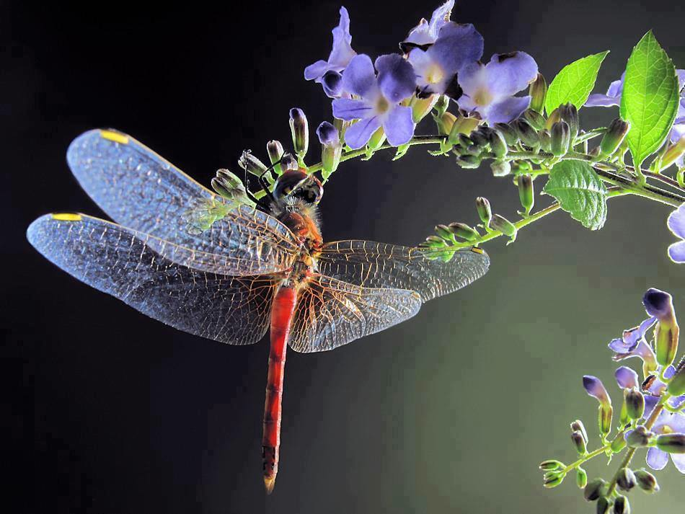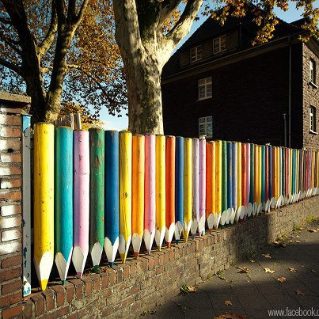

The estimated budget for each site must allow the amortization of construction equipment, of supplies and plan must be established to cover the cost of structures and providing the protocol of using for the duration of the establishing of a rainbow mission, the cost of planting and finally compensation contributors artists and technicians responsible for the installation of the rainbow in the sky. This is to navigate between nature and the lights in a kind of controlled waltz that should lead visitors to dream and make a unique site.
Each facility is expected to shall be subject to a specific study. The project can in no case be sold without prior consultation, site by site to define the nature of the setting and its reality in the proposed landscape. The specificity of each environment will determine the best amenities to advocate, around the theme of light and its rainbow sky rays, the cause of nature.

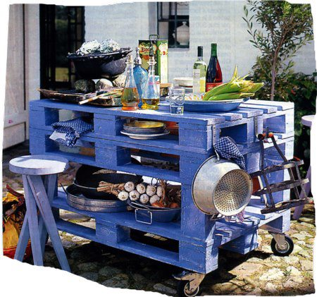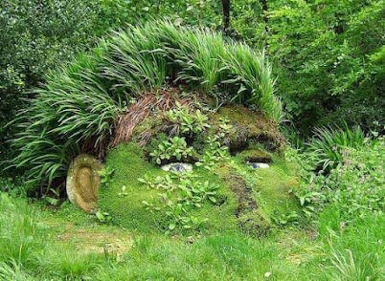

5. To go further
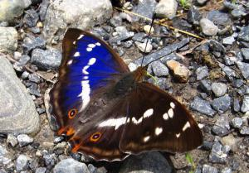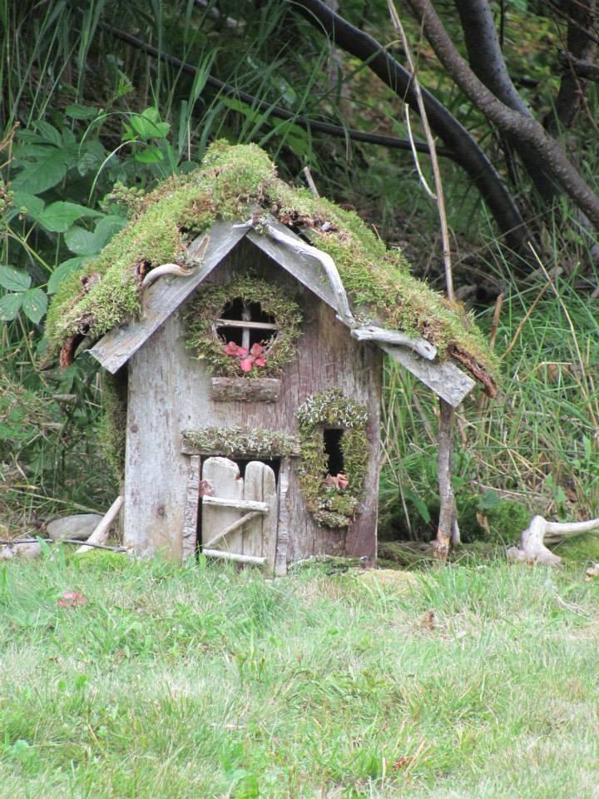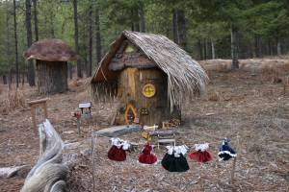
The incrustation of these little touches by the details of the micro-facilities outlined above is specific to spread a handful of dreams at the foots of the rainbows, but also to participate to the wildlife presence (a water trough, feeders, nests ...) and the human, because these birdhouses or those trough should be filled by the local population, which can contribute to social cohesion around the theme of environmental education .
See the dedicated page on the website of rainbowmakers http://lauredupuy.wordpress.com/pour-les-insectes/les-espaces-verts/ which specifies how to maintain and manage differentiated spaces with new recommended management methods in french pilot departments. On this page the methods without pesticides are described very accurately. It includes the installation of bags of ladybugs who are "natural" insecticides of many country ; but also a lots of forms of sustainable maintenance of green spaces, sometimes innovative, but often times empirical lessons that had been lost in recent decades due to the intensive use of chemicals (including those who are the most advances).
A application for mobile phone which will, after a recognition of photographie, give access to a database of information on the plants necessary to wildlife and their uses (medicinal, culinary, in construction, in pharmaceutical), and legends about them : luck, success ... This project is called iFlore the page entitled "educational app" http://lauredupuy.wordpress.com/pour-les-insectes/ and attempts to present each plant with its interdependence with wildlife, inviting children to recognize butterflies in order to arouse their curiosity on this subject in a fun way.
6. Participatory workshops for teens
Learn Wood.

The idea. This is a discovery workshop for young classes. We will select a tree near a water... then, a workshop for each wood processing phase. From wood to paper or to a barrel, a table ... workshops throughout the year. Small water mills, building of birdhouses....
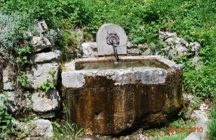
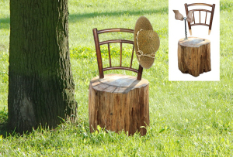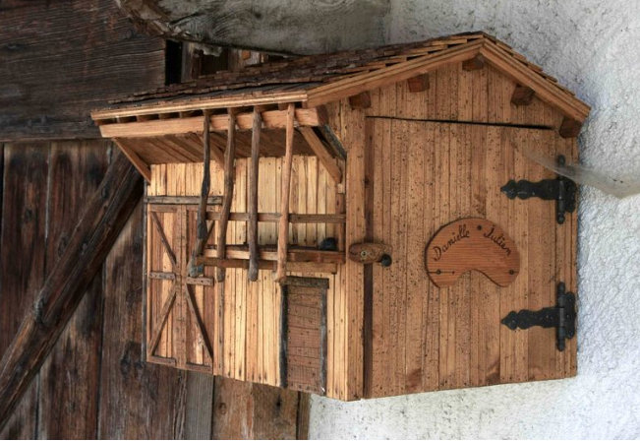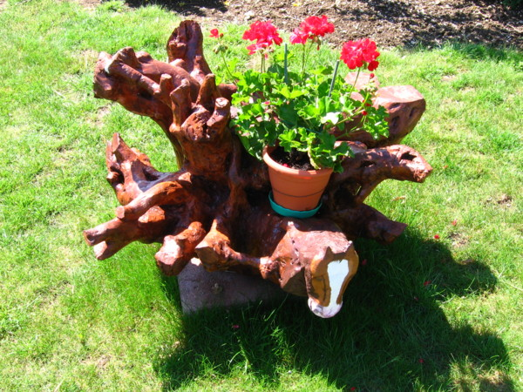

Besides the strain where it can be created a fountain, a workshop is also planned for create a fontain. And a second part of the program of this workshop is to explore and observe the flow of water to the river with observation of the new wetland on the way to the water. Wetlands are uncommon and necessary; it is always important to enhance our efforts in the direction of environmental education.

As for the strain, it will be transform as wood sculpture by children, which can also be extremely amuseds by outdoors workshops.

So many trades will be discovered, as well as the environment and a creative art in plant recycling with recovery of the creativity of children. The ecological footprint concept can also be addressed in these workshops which should ideally be supported by the schools.

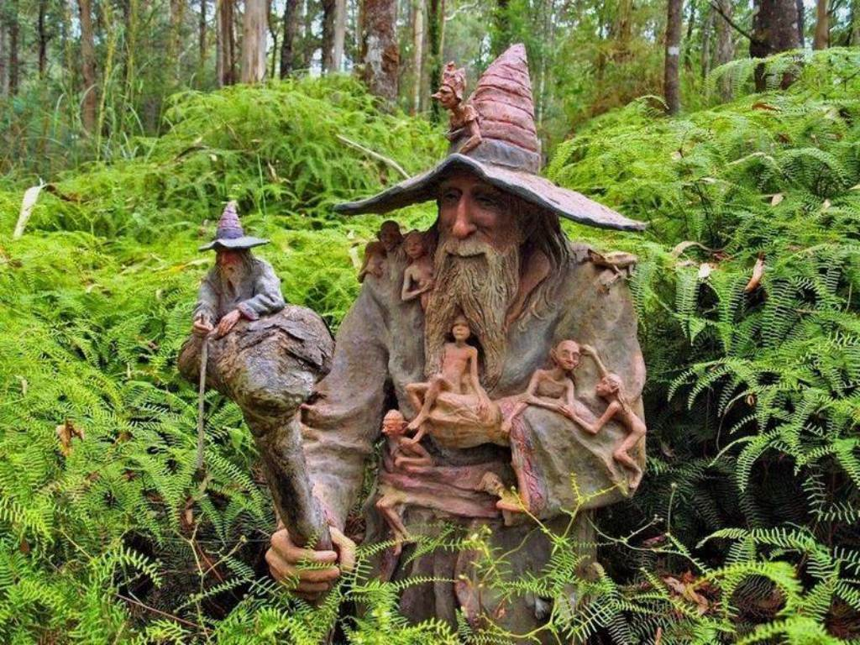
7. The history of the project. All began in Orleans on the Jean Bertin rails ...
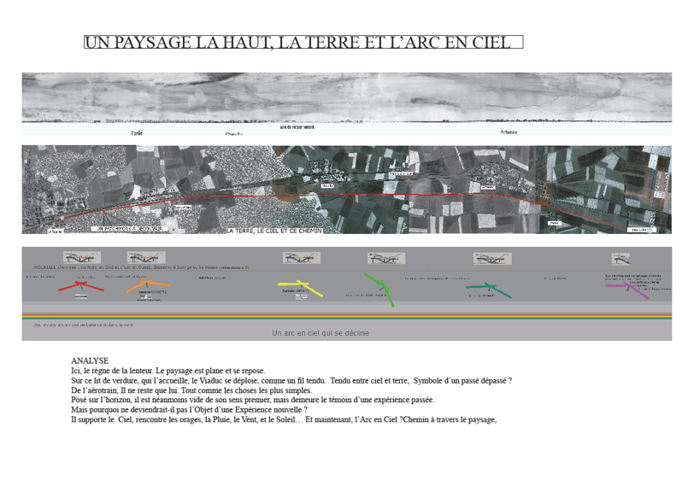
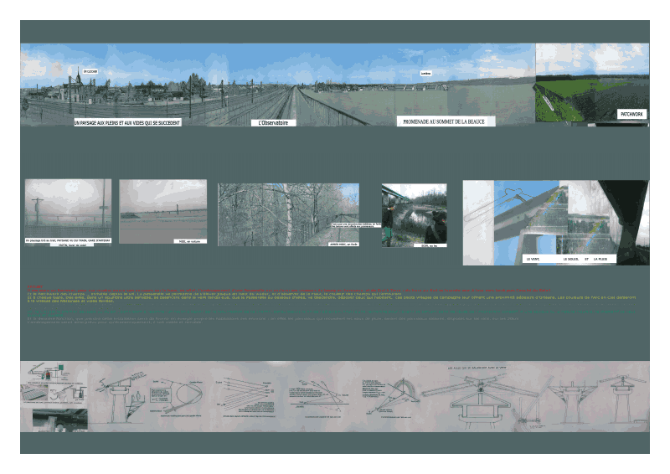
1. The subject of a re-qualification : be an inventor!

The history of the project began in 2007 at the AJAs landscape school where the topic was to create a new landscape with the rails of the Skytrain project abandoned in 1967. These rails perched to 8 meters high and extending for 20 km had to to be thinked as subject of a composition without touching the ground. You had to be an inventor on the subject : it is the beginning of a crazy bet, bring up a rainbow the recovery of rainwater through solar panels tilted connected to high gutters at the top of rails, while redistributing clean electricity to all the surrounding villages. This circuit was triggered, the appearance of the sun, under 42 °, allowing residents and motorists with the sun in the back of seeing a rainbow.
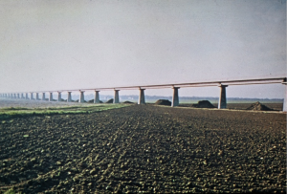 The project was to collected rainwater who would be brought at the base of each pylon in Canadian wells for not to freeze and redistributed through sprays like for greenhouses (pipes all along the rails) to bring up a rainbow sky. Note that these rails are oriented north/south (another necessary condition for having the sun from east to west and so correctly positioned relatively to the wall of water to see the rainbow appears. On the other hand, the rainbow is visible only on one side of the wall of water, morning or evening, because the observer must, to see the show, have the sun in the back. In this case, it was parfait because the road is on the west and so can profit of the performance all ends of afternoons.

Thus, after 5 years, no longer seeking to reuse what appeared to be a very expensive so impractical device, came the day of a decisive discussion which planned to use bridges. Supporting structure for the atomizing device with the necessary and sufficient height for large rainbows with a very lower installation cost ....

2. A project in New York
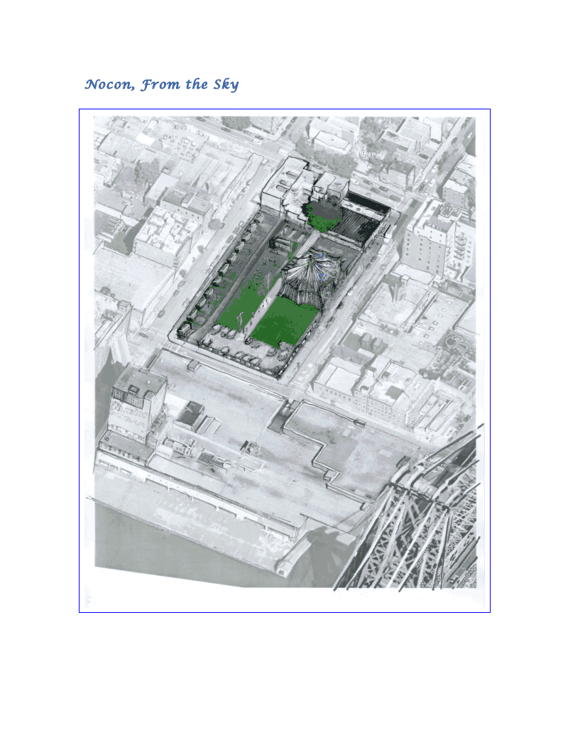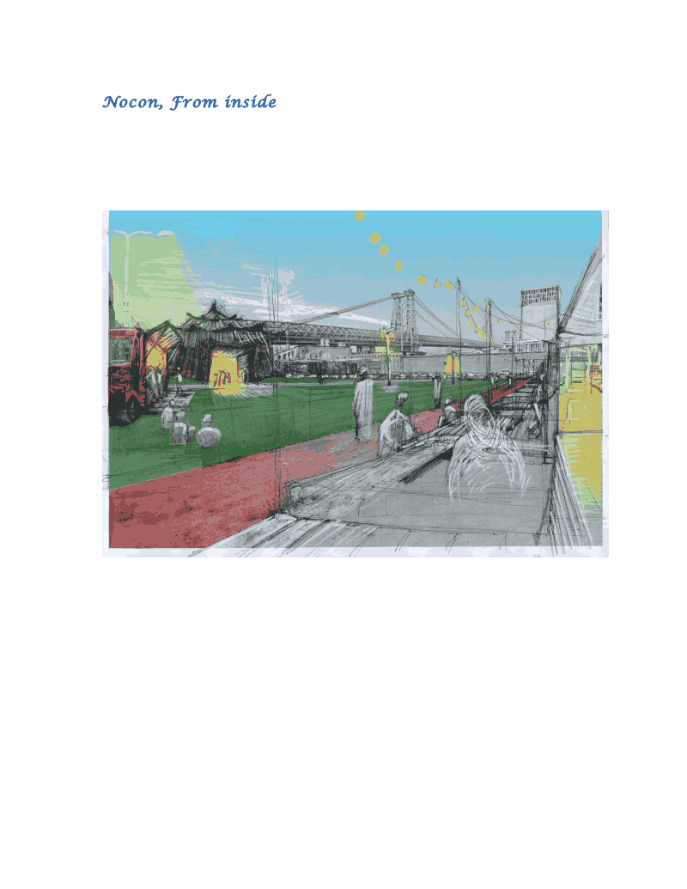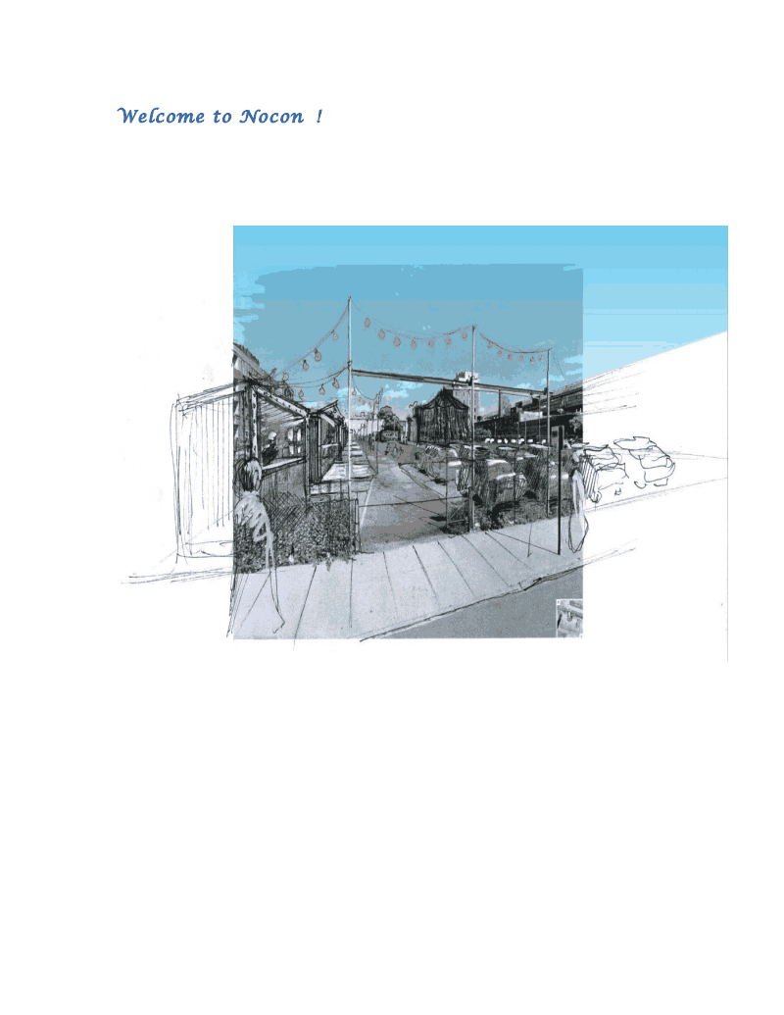

In January 2013, Dominocon company in New York was seeking an expertise in landscape for a development project in Williamsburg next to the bridge, at the site of a former vacant lot, and who was projecting to instal an artist tent for performers, designed to accommodate a variety of shows and public.
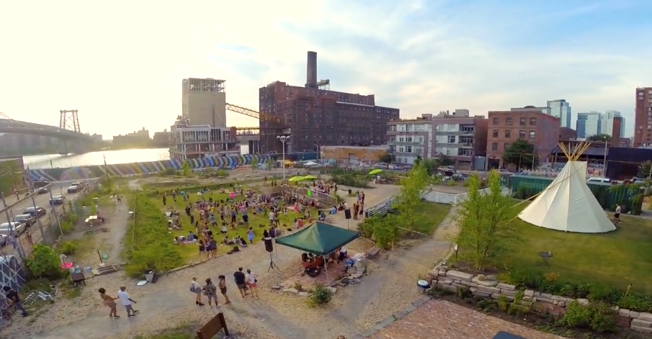

On the occasion of the discussions, the rainbow skies device was mentioned. The question was asked about the possibility to use of the device of rainbows below the bridge. The project took immediate magnitude because it was not only possible, but the cost was reasonable, because of lesser complications. The project will also benefit from a natural height for the appearance of the rainbow in the sky using the support structure. The device had to find his own way of expression through a happy discussion by March 2013, with the artist Frederic Taieb, developer of space. And the idea was born: now we would see rainbows under bidges, but without clouds, supported by bridges. It was still an idea, but the adventure began ...
8. Contacted sites, goal : to convince
The Millau Viaduct
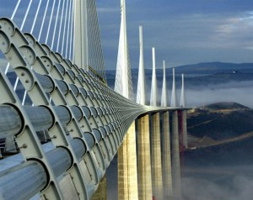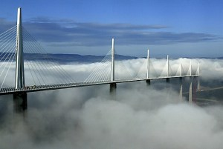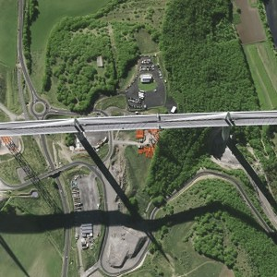

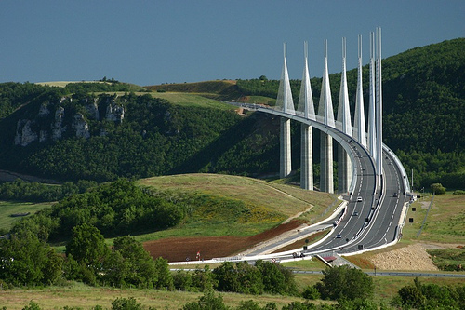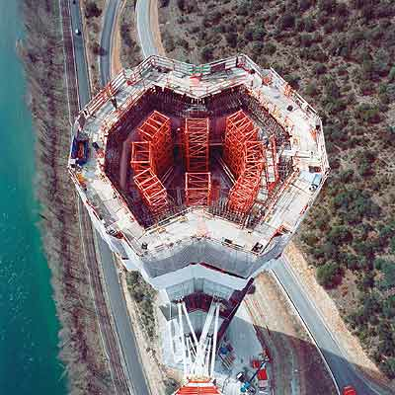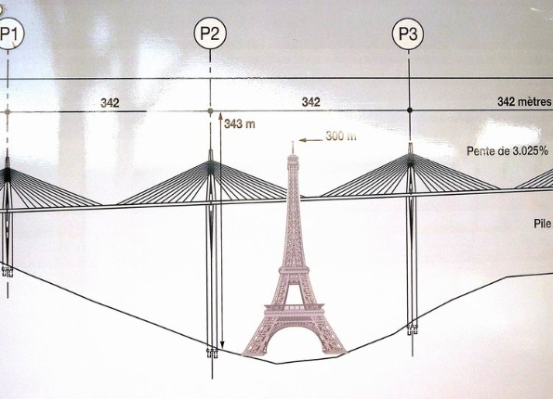

Two obvious factors have led us to move towards the Millau Viaduct. First the project, born in France, sought its natural site in a high construction and of sufficient size to allow the appearance of a rainbow. On the other hand this monument of more than 300 meters high will see the appearance of rainbows in the size of those of nature. The nature of the site allows the naturally cling to the viaduct support.

There is in this simple project of micro droplets walls under the bridge an extraordinary appearance, for the sky may be blue cloudless sky will light morning and evening using the natural cycle of the Water falling in light rain and allowing watering of land that can be embellished plants associated with animals in the region. We offer a range of plants that attract butterflies, and small additional landscaping can be seen in what we called, not just a rainbow but an "rainbow intervention " where development may be accompany of microwildlife. The mist may be accompanied of micro-ecosystems where the magic of air enters into the heart who looks.

The material used is simple; it requires the recovery of stormwater discharged from the highway for spontaneous reuse under the viaduct, whenever the sun shines below 42 °. It is a landscape work of that benefits the entire region.

To conclude : the realization in Millau of a rainbow sky on such a scale is a technological feat ever realised, playing with the elements creating beauty with rain and sun. This grandiose environment, outstanding natural setting, recycling of runoff, serves light pretext to involve plants that depend on bees and butterflies at the foot of the mist, much to the delight of young and old. Et for love of nature.

The Gard Bridge

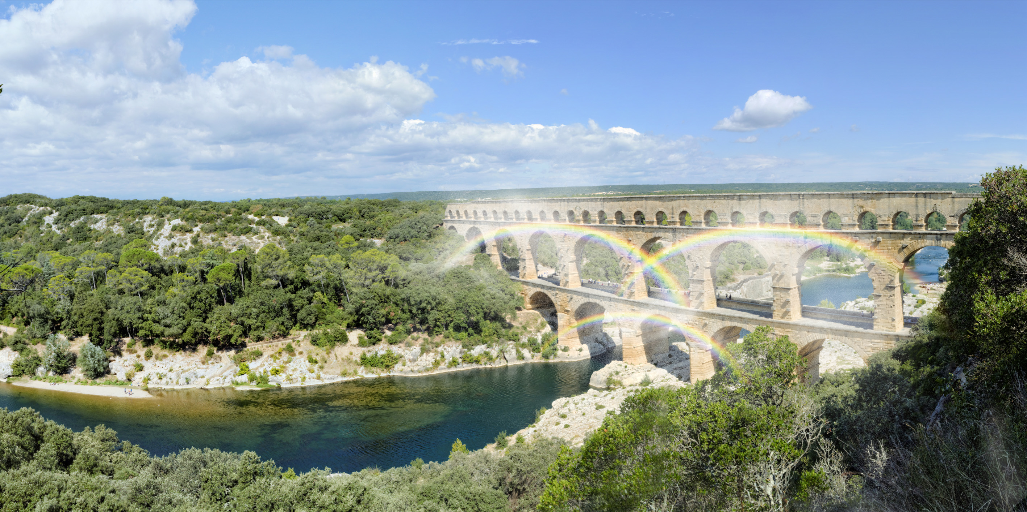

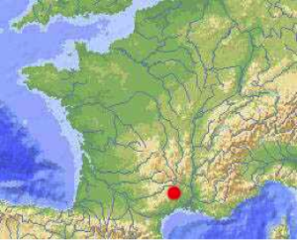

maps Identity "The mythical bridges" Belin edition :

A short history of the Pont du Gard in key dates

40-60 Bridge construction/ III-IV century the aqueduct is no longer maintained and the water flow is reduced/ IV-sixth century diversion of water by local residents/ Sixth century the aqueduct is abandoned / The Middle Age the aqueduct is reused for buildings of locals (churches, houses), widening of pillars to pave the way for beasts of burden/ 1743-1746 construction of a road bridge/ 1840 by Prosper Mérimée registration on the list of historical monuments/ 1844 and 1855 restoration campaign by Questel architects and Laisné/ 1970 closure of the bridge to the vehicles / 1985 inscription on the UNESCO list of World Heritage/ 1997 major restoration campaign

The top floor of the aqueduct, perched 49 meters above the river, which was supporting the water pipe : it was the highest aqueduct of the Roman Empire !
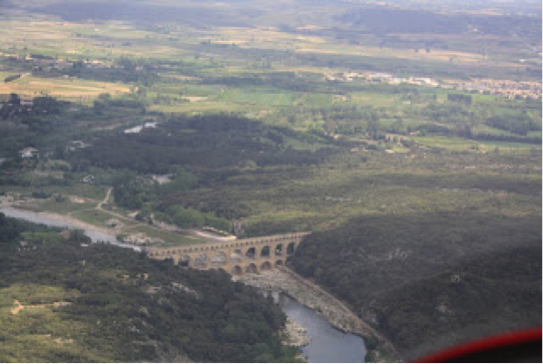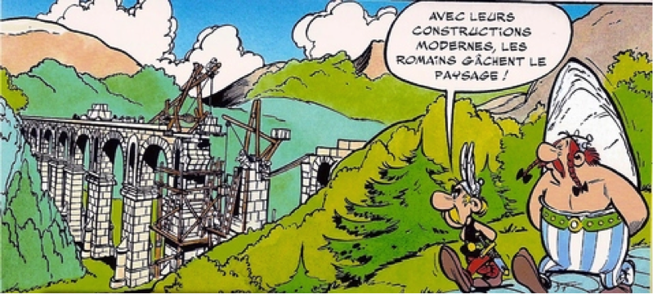
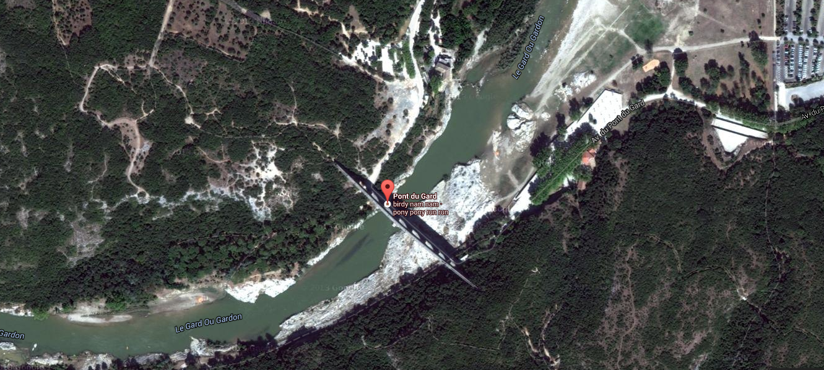
The rainbow of Manhattan and rainbow Lisbon (expected twinning):
inputs to the Continents since the ocean

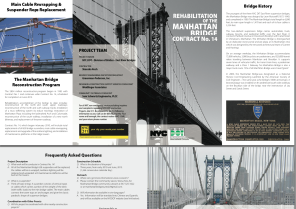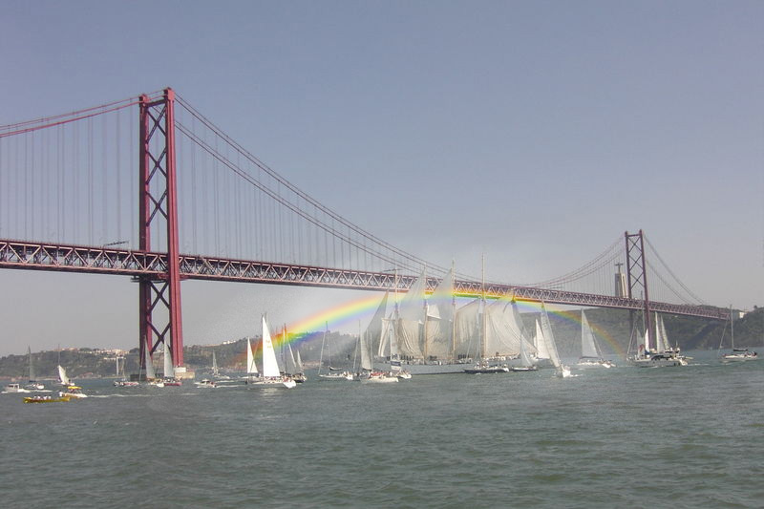

The Manhattan Bridge tells the stars of the city. This magnificent monument dialogues with the sky. The installation would illuminated by dreams. A new day can be born with the conquest of the morning and the sunset. A bow to 7 colors can be part of the history of the Stargate, reflecting all the dreams and all the enchantment. A lots of hopes are borned in this city that speaks to the world with his amazing ability to host new dreams again each time they appear. The opening of the morning sky and the ability to see ever greatest are the characteristics of New York who make this city a place of perfect locality for this project as simple as grand and magical.
HISTORY AND REHABILITATION OF THE MANHATTAN BRIDGE

The youngest of the three suspension bridges over the East River, the Manhattan Bridge, was designed by Leon Moisseiff and completed in 1909. Its total length is 6090 feet, its main span length is 1470 feet and each his four cables is 3224 .In 2009 feet, for its 100 years, the Manhattan Bridge was designated a national historic landmark Civil Engineering.
This particular bridge in New York is a monument and reflects a true excess by its mass and its thousands lights of night, making it shine like thousands of stars in the night.

1. Input / A starry bridge
It is an entrance into the city, landing in America and the American dream. This bridge dialogue both with the city with the sky and water. The project of the rainbow sky can enter the day and evening in the elements related to the show of rainbows.
2. A Monument
The bridge has undergone any recent restorations and is part of a project of modernity and innovation that make it a unique and special place in the history of the city and history to the present. His monumental aspect may well accompany a project as simple as grand, and still meets once at dream that shapes the country and the arrival in America.
3. The Conquest of the day
... Especially the rainbow is a gateway and plays on this idea which governed the entry's principe and adds a symbol of link. The arch, the portal ... this is the entry of the day which will be here an event by the rainbows colors and the output of the day the same way.

A/ Two bridges between Queens and the Bronx.
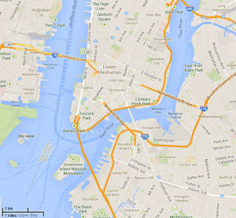
A boat ride far in the lands ....
Follow the river by boat, continue our journey a little further inland. Two other bridges oriented north / south at end this arm between Queens and the Bronx. Thus, the device is possibl, several rainbows may follow along the channel and to tag even better this entry to America, making the trip even more "magical."

B / If the City wants: A Grand Arc-en-ciel in New York may exceed the channel and enter the sky above the City ... A Great Axis: The Hudson River
This project is actually a flagship project. Use the other arm of water entering the land for miles oriented North / South, may, at the request of the city, allow the establishment (prerequisite: raise the pipe, high enough spray clinging to structures already in place along the river or to use the walls of buildings on this shore) a gigantic arch of rainbow above New York. This project can be original and come in a second time. He meets this gigantic city and can be triggered on demand, when the sun shines the morning or evening, a fabulous creation of happiness show and unique.
C / One possibility: a mini bridge ecological corridor and a "walk of rainbow " can be installed like a will to create an ecological event related to this natural spectacle
The development of walks over the bridges on the theme of colors can be also conceived with butterfly's plants on balconys and can be added so that the butterflies fly in the spring in the sky in middle of our rainbows, which brings us to proposals for optional items always interacting with the sky (see section 4).
The ocean surge in the city, the city rises to heaven to tell the history of mankind. New earth which discovers a continent that emerges from the water in the din of the stars.
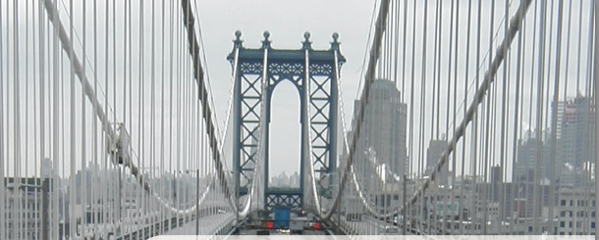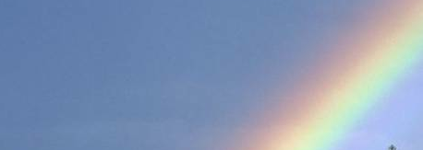

Registration in the landscape on both sides of the ocean:
Arrival in America / Arrival in Europe: Twinning Project between New York and Lisbon, the latter gives also with extremely favorable conditions with the two bridges like a corridor for an entrance in the city.
If New York is a door from the ocean to the Americas, Lisbon from the other side of the ocean is an entry in Europe. Twinning of the two cities, both of which have an input in the city by the river and bridges oriented north / south would agreeing a message of peace in rainbows. They can represent peace and unity throughout the world across the ocean by dialogue between two continents and pehaps more....

Proposal for Lisbon

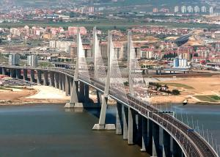
The two suspension bridges at the entrance of the city: the bridge April 25 and Vasco da Gama Bridge are both idyllic's brackets to install a rainbow trigger ... They are oriented north / south and the sun happening from east to west, with magnificent performances at sunrise and sunset. In the situation of the city, a mere trickle launched when the sun is in the right place will be enough to illuminate the city, offering the unusual and unexpected sight of a rainbow sky every night and every morning the sun .
From where will we see the rainbow?
From every point of view where we see the bridges with the provided you have the sun in the back:
• in the evening we will see the rainbow above the Vasco da Gama Bridge and over the bridge of April 25 from the west of the two bridges, that is to say from the bank at the Infante Avenue Dom Henrique and from the opposite bank to the bridge and VDG from Brasilia and Porto Brandao Avenue.
• In the morning we will see two rainbows in the sky from the shore to the east of the bridges.
• Morning and evening, on the heights, whether one is in the East or in the West, always with the sun in the back. And the show should be simple but great.
9. Adaptation For cities
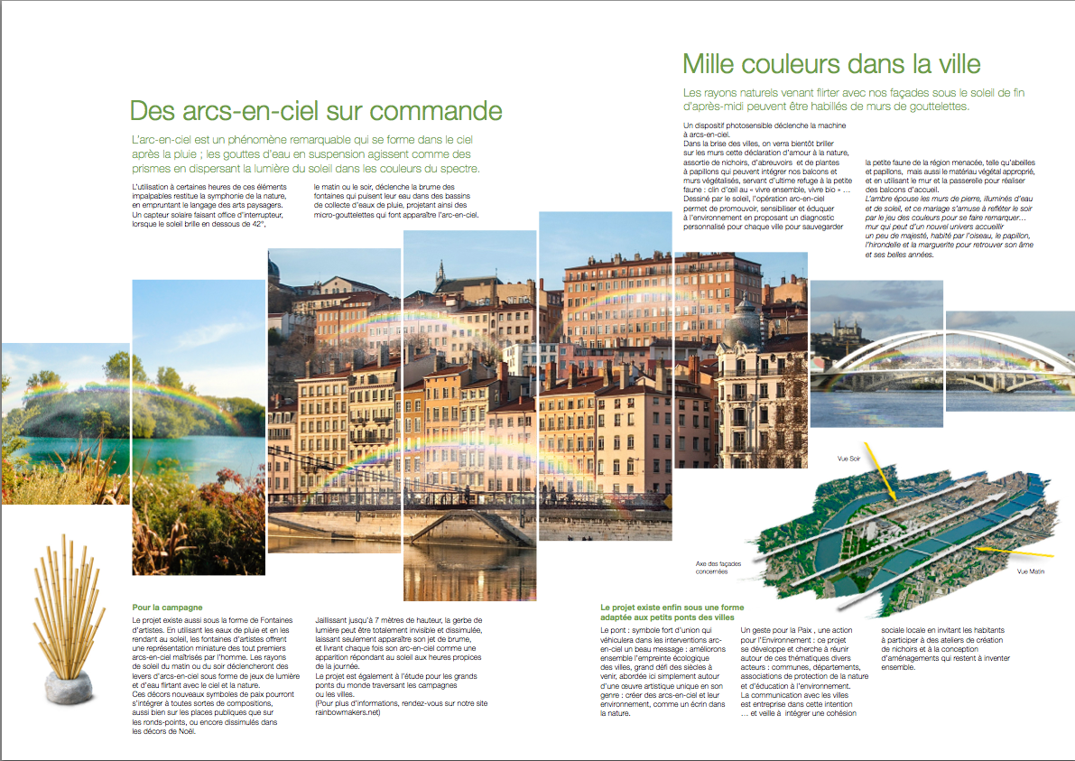
10. Adaptation to the parks and gardens

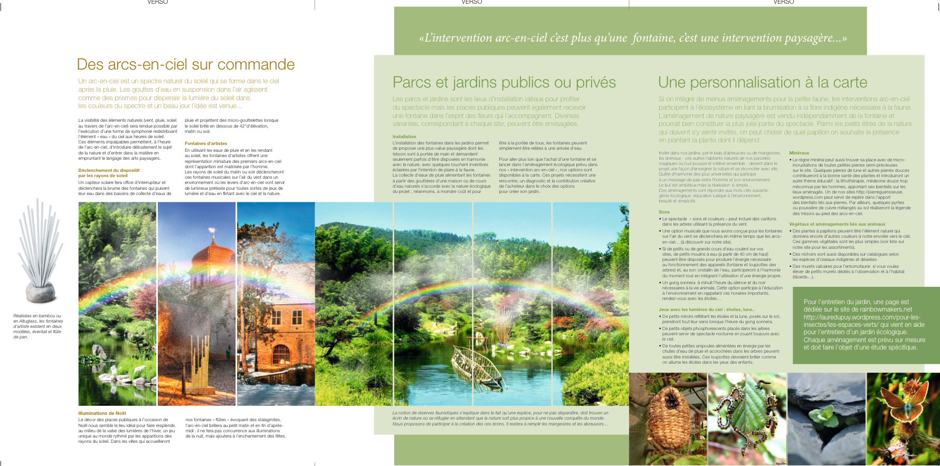
11. Project leader and presentation of the adventure of a team
Admitted to the college of art garden architecture and landscape in 2003, Laure Dupuy is brought to dial in the context of its various studies and urban amenities and city's furnitures. His passion for garden's action begins in 1989 with a subject of draw's art. Law student, then at the Paris School of Architecture la Villette, Laure, too opposed to modern limits of the use of materials in modern architecture, deserted quickly these studies. After a time of reflection, successively in the commercial sale of advertising space and mission in law firms, Laure decides move in landscape art. In Paris she has difficulty in learning the plants so she designs for urban youth a learning tool to identify plants, materialized in the project and still programmed (shown here: http://rainbowmakers.net to educational app section).
To push further his research in learning from nature, Laure realizes for graduation a typology of educational garden (related to the theme interaction and interdependence fauna / flora) enjoying the protection of small animals by participating in the national directive and internationally to promote native plants in urban developments. Then admitted to the Atomic Energy Commission for training focused on the prevention of major risks with regard to climate change, she quickly leaves; and she was admitted the same year in master 2 of the Institute of European Studies, where she undertakes an analysis of the state of development of environmental education in the world, studying particular all countries ahead in this teaching ...
It was at this time that she associates with Jerome Kardos which will therefore remain a permanent partner on all related productions between them and now designated as a whole under the name of "I want to know everything." Jerome buttress her and, together, they will design a series of all projects focused on education: the passion of two partners joined beautifully on this subject, their ambitions did equally as great desire to do well without further consideration in the first writing as feasibility, relegating funding concerns later provided the economic model is viable: they dared to believe that it is key to think freely about how to improve the world and that later would come from other means, other projects that would achieve the greatest because gradually the bird makes its nest .... From the beginning, their main theme was environmental education, so important when it requires unprecedented growth for the sustainability of human settlements. The result in 2008 a major project of educational cartoons on this subject, unfortunately abandoned for lack of funds and because of the release on television the following year of "once upon a time the Earth" which deals according to their intentions part of the recommended program. But a second part of the program: the transformation of "Hulotte" (Comic education to nature) in cartoon remains to be done and also within the forecast of "I want to know everything" (found on the rainbowmakers.net site all the projects mentioned here).
Soon Francis Cohen-Seat and Maureen Chatel joined them, but the group ran out of steam soon with the lack of money, even if the overall project is improving, thanks Maureen brings its share of creativity to every project she touches . Mr. Cohen-Seat then headed what was then a trio to more feasible projects that all general education program in cartoons. In 2009-2010 they design together an educational application (still on the topic of environmental education) iFlore, playful concept of recognition with photo of plant who, seeking more than a strictly botanical speech and offers everyone to discover useful knowledge about the flora from which depends fauna (and the opportunity to run after butterflies for children), culinary and medicinal uses of wild plants ... and invites to plant these native plants.
Later, in 2012, a new encounter with Frédéric Taieb open new ideas. Based in New York, he wanted to create in the layout of meeting places of the territories on the theme of co-creation, gives new life to the project that takes then an international dimension; it will be reinforced by the entry of Mr. Alan Skoro that will carry associative and artistic projects to other borders, for already the spirit of this project matures and travels.

An associative project was launched in 2013, which would be ideal as support for educational cartoons as they were designed in the early hours. This project is of general interest : he seeks how to promote education, fight against isolation, bring education within the reach of the poor by offering dedicated schedules, create a social and local cohesion around the theme of education. This model is offered to all available online. It is designed as a suggestion box containing all our fun tricks in education and associative portage. It is reproducible and freely adaptable. The first association seems to OJ early 2014, the first educational display opens its doors and now offers support for associations using the model of educational pilot screen and Tohovia humanitarian association: it goes up a clinic in Benin street children and organizes volunteer tutoring in France for the children of migrants in difficulty in the context of a shared room between the two associations. The goal is to get the support of Education and to give, lent for use, for neighborhoods the documentaries of CNDP and CRDP (of french ministry of education) .
Since January 2013, Laure and her team provide a work for an international and Artistic Gesture for Peace in the World described in this brochure. The team is approaching in 2014 the Ministries concerned, the Millau Viaduct, the Pont du Gard, and a number of town halls. On his first trip to Millau to meet Eiffage (of Viaduc from Millau) without raising the expected enthusiasm, but will make another decisive encounter in the person of Mr. Loic Petrignani which brings a new skill to the team with its fascinating creativity in the technical field and the plurality of solutions for achieving perfectly mastered the project.
The version "fountains" of the rainbow sky project is the spark to allow the dream, to be realized on a small scale by being made available to all while keeping the original spirit in order to develop gradually its full potential. This team knows that valiant heart believe nothing is impossible and that always move a dream, he can become reality.
The project, which all share their dreams in the consciousness of reality, offers ideas to participate in the education of nature and propose to make a event with it, innovates and give a positive speech in its advances in terms of footprint in the environment and throw a celebration with it. This project will be a successful, and he will be a collective success if everybody smiles.
Conclusion

This is to rely on the symbolic force of crossing a bridge to evoke a message of peace throughout the world, a light in the sky, which is sufficient to evoke our sunny mornings or sundowners. All this would probably perceive the flash of a smile on some faces sketched children.

Perhaps after all, if the sky appears without clouds, the rainbow then having his evocative purest and most authentic, are we able to talk about a peace message immediately perceived by the most innocent, despite mists or life events that would mitigate the beneficent clarity ...

Walkways and bridges do not they have the primary symbolic and universal vocation of transmitting the message of brotherly love between men, regardless of the hardships encountered over time and sacred and secular spaces, as suggested by the the oldest traditions.

This simple message sent as a fleeting star dust reduced to our earthly years could identify with the search for our hopes of peace, love, happiness, perhaps brought to infinity or simply in the sacred time For a moment, indifferent to our secular marks clinging to notions of time and space.

The bridge and the man : a love story ... a link between people, a link cut by wars and rebuilt by the peace...
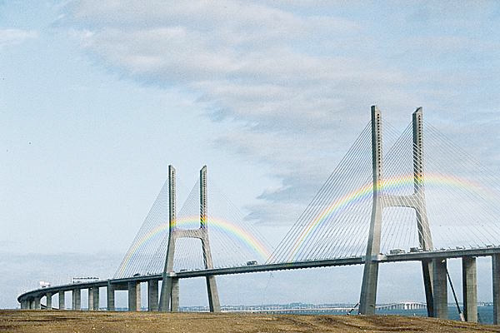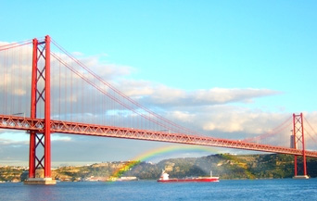

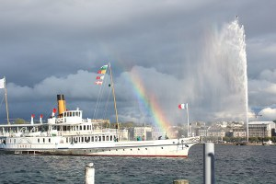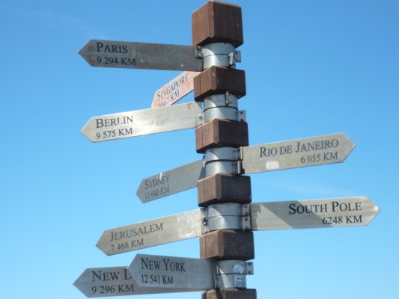

Let us at this time the beautiful introduction to the art of bridge

"Young, I visited the Pont du Gard, bike, as did, on foot, Jean-Jacques Rousseau and others. We discovered it around the corner. Neglected, abandoned, he served more than anything, nor water, nor road, no museum piece. Heavy masses, sometimes standing out from him, fell like the hair of a hoary head. The antediluvian monster slept across the valley. Sparrows, doves, kestrels, nesting under its arches and around fluttered. We went diving into the Gardon and lying on the shore, with the bike, you could hear the wind vibrating among its multiple batteries. Was regarded as a fossil. Few people ventured to this lonely place, thorny, rocky, overgrown silence screeching of cicadas. The disjointed stones of the aging bridge eventually mimic the rocks of the landscape. Forgetful of technique and culture, the book based on the life of nature. Rousseau was wrong : we forgot the legion, the Romans and their train, the conquest of Gaul and the memory of the battles to not see, confused, a vertebral bone bridging hardened coast geology. It served as counter-historical time my youth: I left ten massacres, we needed oblivion. »

Introduction of "The Art of Bridges" Michel Serres

How many works dealing with bridges, their history, their language, their symbolic too, start with this first landmark, ancient bridge that honors the art of our human construction. Through these monuments crossing obstacles that cross ditches and rivers from these invisible barriers, the man will try to avoid obstacles and forge his destiny without being entertained by the pretenses of a impenetrable reality.

The man full of dreams and hopes asserts the contrary, the mind and the heart, all his art to innovate and create, in spite of all obstacles and trials of life.

The man stands in the magic of construction and more than ever in the bridge, these useful works of art that have made necessary and always apply to make beautiful ...

The history of the bridges is a world history. At each people its way to create and think. Technical traveling without borders, human cooperation, visible and admirable in landscapes that are as varied as devoid of illusory borders..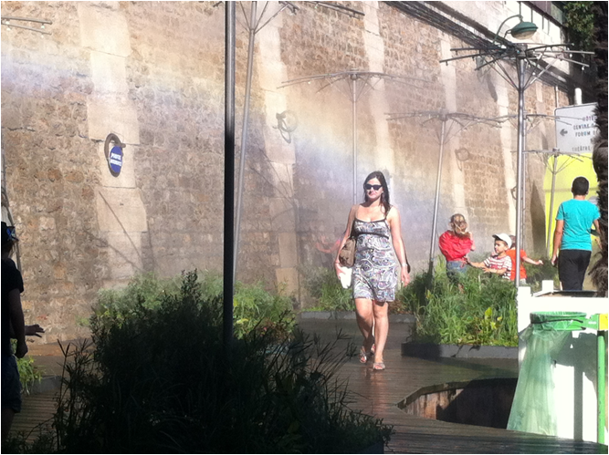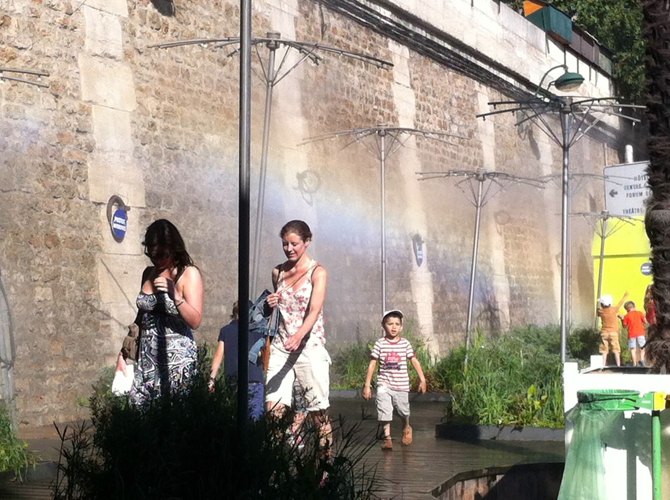

Our works through obstacles will even become Force of peace and union. If the bridges connect and meet men, wars have always been rather triggers destruction and chaos. Bridges that are slaughtered in wars still prove that our bridges are our human constructions, one of the strongest symbols of peace and connection between people.
It is here that our little piece of history, wanting to bind these symbols a gesture, a message of peace, of course, use these tall structures that draw lines, stretched in the air lines. Here we want these traits sign peace this year, next year .... We want to open a time of peace, light prayer based on water and air and sunshine building on the land, a colorful gesture in the air using the latest rain to make the sun. The rainbow of peace appears as a glowing tribute to the Light. The natural cycle of the elements, the gap between the rain and the sun is supported in this human gesture, very human, that will pass through the elements, to make a show, a speech, a glow in the sky that says this peace for children, this universal smile that did not need words but speaks so well. Draw a rainbow is to draw a smile that has crossed the barrier of peoples and languages ....
Water, light, life
Without water, no life ... water place between heaven and earth that perpetual journey called the water cycle. This is where we get into this cycle by subjecting the water to light, at the right time, to make him draw a line of seven colors that smiles and believes in the future.
As it celebrates life, together, do shine bridges around the world, in every season entry, March 21 June 21 September 22, December 21, light rigs tokens overcoat borders, to dream, celebrate and establish peace.
... Peace in the world, a sign of peace, a light of happyness.

Work written and directed by Laure Dupuy with the support of Jérôme Kardos, Fréderic Taieb, Marie-Christine Dupuy, Loïc Petrignani, Alan Skoro, Vera Albino, Maureen Chatel, Éric Fitoussi, Thomas Dupuy, Guy Dupuy and Anaïs Boulain,.

Contact : Laure Dupuy +33623035533 arcencieldepaix@gmail.com ou lauredupuy@live.fr

